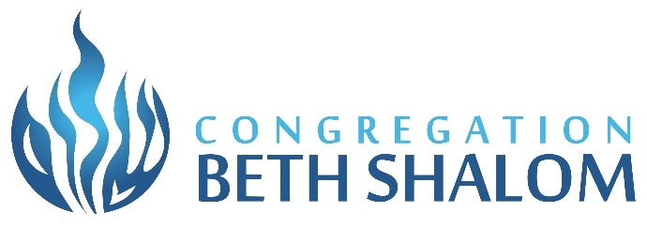
Kiddush Agreement

Dear Bar/Bat Mitzvah Parents,

Congregation Beth Shalom would like to wish you a hearty Mazel Tov on your upcoming Simcha! As your child’s Bar/Bat Mitzvah approaches, I would like to share some important information regarding the Kiddush luncheon on that special day. CBS manages all aspects of the Kiddush. We are here to work with you.
CBS encourages a feeling of community by hosting a Kiddush Luncheon after services each Shabbat. It is our policy that B’nai Mitzvah families help financially support the Kiddush Luncheon following the celebration of their child’s Bar/Bat Mitzvah. We ask that the signed Kiddush Agreement be submitted four months prior to your Simcha and full Payment be made two weeks prior. Please feel free to contact Executive Director Michael Garlin if you have any questions or concerns regarding your financial obligation.

You will be contacted three (3) weeks before your Simcha to get a final count of your guests. It is very important that you provide an accurate count; the amount of food ordered and the number of tables used is dependent upon the numbers you provide. Clergy, staff and children five years or younger do not need to be included in your count.
A shortage of food and seating embarrasses everyone.

CBS would also like you to be aware of the following synagogue policies:

- The Kiddush is a community meal for which the entire Congregation is welcome to participate.
- One or two tables will be reserved for the immediate family of the Bar/Bat Mitzvah.
- NOTHING CAN BE BROUGHT INTO OR REMOVED FROM THE SYNAGOGUE ON SHABBAT OR HOLIDAYS.
- Any specially ordered kippot, personalized napkins or décor must be brought to the synagogue before 12 Noon on Friday. (For your convenience, CBS Sisterhood can order personalized napkins and Kippot (See Page 12).
In accordance with Kashrut and Sanitation Guidelines, CBS will provide all food unless an approved Caterer has been contracted (See Page 9)
- Other families who may be celebrating a simcha on your day may choose to add items to the Kiddush menu. If this should happen, that family is responsible for ALL costs associated with the addition, including paying for all of your guests.
- Please notify CBS of any bus transportation to a party or luncheon that may take place after services.

* Please inform us of any known food allergies or dietary restrictions.
.
Again, Mazel Tov on reaching this exciting milestone!

Warm Regards,

Randi Simon

CBS B’nai Mitzvah/Kiddush Coordinator
847.498.4100, x23
rsimon@bethshalomnb.org

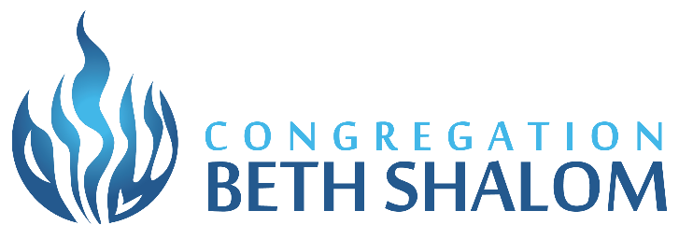

Basic Kiddush and Basic Plus Kiddush
$500 Host fee
plus $14 per guest

BASIC KIDDUSH MENU BASIC PLUS KIDDUSH MENU
Tuna salad Basic Menu plus your choice of the following options
Mixed Green Salad w/Assorted Dressings Additional Options:
Challah and Asst. Bagels Mac & Cheese: $4.00 per person
Plain Cream Cheese Sweet Noodle Kugel: $4.00 per person
Fresh Seasonal Fruit Cheese or Vegetable Pizza: $5.00 per person
Assorted Bakery Goods Specialty Salad: $5.00 per person
Coffee/Decaf/Tea/Kiddush wine Egg Salad: $3.00 per person
Lemonade
Table skirting

Please note: CBS can only provide one Basic Kiddush per Shabbat.

If sharing a Kiddush with another family,
all additional options must be agreed upon by both families.

CBS reserves the right to substitute food based on availability
Prices are subject to change

Extended Kiddush Option I
$850.00 Host Fee
plus $24.00 per guest

MENU:

Tuna salad
Egg salad
Sweet Noodle Kugel
Choice of Salad
(Mixed Greens, Caesar,
Israeli,Chopped or Orchard
Hummus and Fresh Cut Vegetables
Lox spread or Chive Cream Cheese
Plain Cream cheese
Challah
Assorted Bagels and Challah Rolls
Seasonal fruit
Fancy pastries
Assorted bakery goods
Lemonade
Coffee, decaf, and tea
Kiddush wine
Buffet table linens
Table decorations and skirting
Choice of Personalized colored Napkins

Please note: CBS can only provide one Extended Kiddush per Shabbat.

If sharing a Kiddush with another family,
The menu option must be agreed upon by both families.

CBS reserves the right to substitute food that it deems comparable.

Extended Kiddush Option II
$1200.00 Host Fee plus
$30.00 per guest

MENU:

Lox
Tomatoes, Cucumbers, and Onions
Plain cream cheese
Chive cream cheese
Tuna salad
Sweet Noodle Kugel
Hummus, Fresh Cut Vegetables, Pita
Choice of 2 Salads
(Mixed Green, Caesar,
“Israeli”- Tomato,Cucumber,Onion,Parsley ,
Chopped- Mixed Greens,chopped tomato,carrot,red/green pepper/ditali pasta
Spinach/Strawberry,Walnut/ Strawberry Vinaigrette)
Challah
Assorted Bagels and Challah Rolls
Seasonal fruit
Fancy Pastries
Assorted Bakery Goods
Lemonade
Coffee, Decaf, and Tea
Kiddush wine
Buffet table linens
Table decorations and skirting
Choice of Personalized Colored Napkins

Please note: CBS can only provide one Extended Kiddush per Shabbat.

If sharing a Kiddush with another family,
the menu option must be agreed upon by both families.

CBS reserves the right to substitute based on availability.
Prices are subject to change

YOUR TIME LINE

- Four (4) Months prior to your Event – A signed copy of the Kiddush Agreement must be submitted to the Shabbat Kiddush Coordinator. Keep a copy for yourself.
- Three (3) weeks prior to your Event - Final numbers are due to Shabbat Kiddush Coordinator.
- Two (2) weeks prior to your Event- ALL fees must be paid in full.

BAR/BAT MITZVAH KIDDUSH AGREEMENT FOR SHABBAT KIDDUSH
(DO NOT USE FOR A CATERED KIDDUSH)
Return to Shabbat Kiddush Coordinator no later than Four (4) Months Prior to your Event

Family Name: _________________________________________________________________

Bar/Bat Mitzvah Name: ________________________________________________________

Parents Names: ________________________________________________________________

Simcha Date: __________________________________________________________________

Address: _____________________________________________________________________

City: _________________________________________________________________________

Home Phone Number: _________________________________________________________

Cell Number: _________________________________________________________________

Email: ________________________________________________________________________

Kiddush will be Sponsored By:
(This will be the wording in the Shabbat brochure.)

______________________________________________________________________________

______________________________________________________________________________

______________________________________________________________________________

Please let us know what kind of Kiddush you would like:

BASIC KIDDUSH

1. _______ Basic Kiddush - $500.00 plus $13.00 per invited guest

Estimated Number of Guests: ________________________

2. _______ Basic Plus Kiddush – Items you would like to add to the Basic Kiddush: ________________
____________________________________________________________________________________________________________________________________________________________________________________

(We will contact you three (3) weeks prior to your Simcha to determine exact number of invited guests attending).

EXTENDED KIDDUSH

3. _______ Extended Kiddush - Option I $850.00 plus $23 per invited guest

Estimated Number of Guests: ____________________________

4. ______ Extended Kiddush with Lox - Option II $1200.00 plus $30.00 per invited guest.

Estimated Number of Guests: ____________________________

We will contact you three (3) weeks prior to your Simcha to determine the exact number of invited guests attending).

We know this is an estimate. You can change the number when we contact you.

Round Table Linens
_____ White Plastic Cloths
_____ Linens ordered at an additional charge of $12.00 per guest table (for all guest tables in the room)
Choice of color to be agreed upon by two families if sharing the Kiddush.
Personalized Napkins are included in the cost of Extended Kiddush (option I and II)only.
Name to be printed_________________________________________( )Block ( )Script
Color of Napkin _______________________ Color of Name ______________________

Leftover pastries - Do you wish to donate any leftover pastries or do you prefer to pick up any non refrigerated leftover pastries on Sunday morning? Per Sanitation Guidelines, no other leftover food will be available for pickup.

____ Donate pastries to Minyan or other programming ____ Pick up pastries on Sunday morning

Accuracy is imperative since the lack of food embarrasses you, the hosts, as well as CBS and the Congregation. Please do not underestimate your guest count.

Please contact Randi Simon, the Shabbat Kiddush Coordinator, should you have any questions: 847.498.4100, x23 or rsimon@bethshalomnb.org.

You will be contacted approximately three (3) weeks before your Kiddush for your final count. You will then receive a final bill. All bills must be paid-in-full two (2) weeks prior to the Kiddush.

Bar/Bat Mitzvah Parent Signature: _________________________________________________

Date: __________________________

Please make a copy of this information for your records.

CBS reserves the right to substitute food that it deems comparable based on availability
Prices subject to change without prior notice.
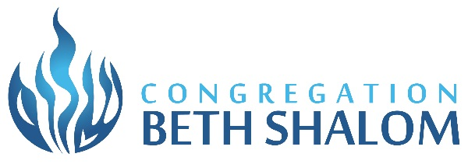

Optional : Catered Kiddush

If you choose to have your Kiddush catered by one of the kosher caterers approved for Kiddush at Congregation Beth Shalom, you will receive a $450 discount on your B’nai Mitzvah Commitment Fee. Your Kiddush must include the congregation and cannot be private.

You may select from the following approved kosher caterers:

- Goldman Segal Kosher Caterers
David Segal
www.goldmansegal.com
847.675.4060
- Shallots Catering
Bea
847.677.3463
3. Starr Kosher Catering/Chicago Tailgator
Karen Gaba
StarrKosher@gmail.com
773.465.6247

- Zelda’s Catering
Kathy Ramos Kurland
Kathy@Zeldascatering.com
Merry Jean Nano-Lee
Merryjean@Zeldascatering.com
847.674.0033

For more information contact Maria Catezone 847.498.4100, mcatezone@bethshalomnb.org
Or Jill Olefsky , Catering Chairperson, 847.272.1758 , jolefsky@aol.com.

Our Kosher kitchen is only able to accommodate one (1) of our caterers per weekend. After a caterer has been scheduled to be used for any reason on a particular weekend, only that caterer can be used for another event that same weekend. This also applies to using a caterer for your Kiddush or Oneg Shabbat. Since this process is implemented on a first come, first serve basis, it is important to contact Maria or Jill to schedule the use of a caterer or check on availability.

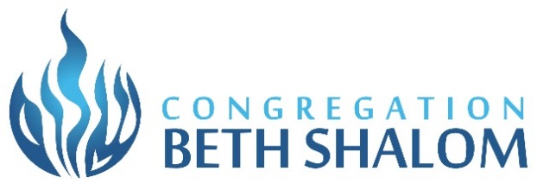

Drop off Friday Night Dinner:
Up to 40 guests: Base fee $200 + $100 Non-Refundable Security Fee
Up to 80 guests: Base fee $375 + $100 Non-Refundable Security Fee
Up to 120 guests: Base fee $500 + $100 Non-Refundable Security Fee
- Base fee
Includes round guest tables, folding chairs, white skirted rectangle buffet tables, white skirted drink table, salt and pepper, ice water, coffee, tea, sweeteners, creamer, motzi table, hand washing table and a kitchen staff. This base fee does not change if congregant does not use all of the above.

Additional $2.50 per guest will be charged if using Beth Shalom white plastic tablecloths for all tables, disposable paper goods and flatware.

Because storage needs to be arranged, requests to bring in other items must be made via email at least a month before the dinner to Maria Catezone, Office Manager, at mcatezone@bethshalomnb.org. These items include, but are not limited to:
Flowers in vases
Kosher Wine unopened
Rented Linens
Disposable paper goods – UNOPENED BOXES/BAGS of
Plates, napkins, plastic flatware, tablecloths
Soft drinks unopened
Any items being brought in for the dinner (excluding drop off food and anything supplied by restaurant/caterer) must be in the building by 11:00 am Friday before the dinner. If not received at the synagogue by Friday, we will provide white dinner plates, paper cups, white napkins, white plastic flatware and white plastic tablecloths at an additional charge of $2.50 per person.

Prices Subject to Change
Without Prior Notice

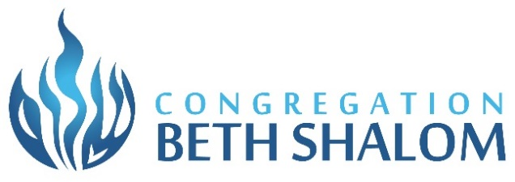

Drop Off Dinner Friday Night
Approved Restaurants/Caterers
Drop off food, with directions for reheating and anything else supplied by the restaurant/caterer, must be delivered by noon Friday, day of event.
EJ’s Pizzeria | 224-534-7215
Emma’s Bagel Café | 847-673-3030
Goldman Segal Kosher Caterers | 847-675-4060
Hamachi’s Sushi Bar | 773-273-6904
Jewel Kosher Department  (Highland Park, IL location-no delivery) | 847-579-0872
Ken’s Kosher Diner | 847-679-4030
Milt’s BBQ for the Perplexed | 773-661-6384
Mizrahi Grill | 847-831-1400
Sandwich Club | 847-677-6020
Shaevitz Uptown BBQ | 847-432-7310
Shallot’s Bistro  Starr Kosher/Chicago Tailgators | 847-677-3463  773-465-6247
Taboun Grill | 847-965-1818
Taco Gingi | 847-983-0648
Zelda’s Catering | 847-674-0033
Desserts
Cinnaholic (Evanston location)  Highland Pop | 847-425-0239  847-433-4200
Illinois Nut and Candy  North Shore Kosher Bakery | 847-677-5777  773-262-0600
Nothing Bundt Cakes (Deerfield location) 847-315-9077
Shalom Bakery 847-808-9300

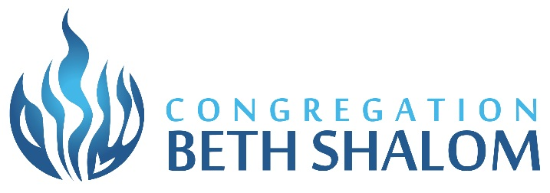

The Simcha Shop

For your convenience, the Simcha Shop has a full line of napkins for your Simcha. Please call our Simcha Shop Chairperson:

Suzy Hakimian 847-205-1488

Louis Gurvitz Memorial
Sisterhood Judaica Shop

The Judaica Shop offers a selection of Tallitot, Kippot, Tefillin, Kiddush Cups, Candlesticks, and other Judaic items.

The Sisterhood Judaica Shop Co-Managers will be happy to assist you:

Diana Lewis 847-903-6175
Darlene Padnos 847-2174531
Donna Fox 513-378-2491

Photographs & Videos

Please call Maria Catezone at CBS 847-498-4100 Mcatezone@BethShalomnb.org
to set up your appointment for your photos and/or videos.

