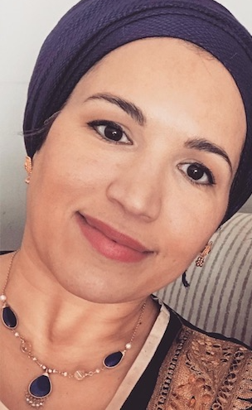

**Emunah Almansoori**

**Bio**

Emunah Almansoori is a fascinating character: Born in Dubai and raised in Bahrain as a Muslim, she moved to America and grew up in Arizona, met hit rap singer/Nazir Ari Lesser and converted to Orthodox Chabad Judaism. She was Reem Almansoori and now is Emunah Almansoori. Emunah does a cooking demonstration of dishes that are shared by Muslims and Jews while telling the story of her personal journey.