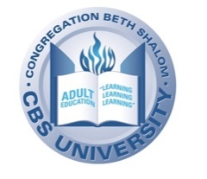
Israel in Depth | 2021-2022

TOPICS

10 / 24 Beyond Lockdowns and Unrest - Is it Time to Travel to Israel Again?: Israel has led the way in managing the Pandemic, and it's worked hard to quiet the unrest that erupted in May 2021. How did they do it? Is now the time to plan a visit?

11 / 14 | How Did 'Zionism' Become a Dirty Word? | 12 / 12 | Satire and Standup in the Holy Land
1 / 16 | Prospects for Peace, 2022 Edition | 3 / 20 | The 4 (or 5) Tribes of Israel
4 / 3 | Israel to the Rescue!

All sessions will be taught by Carl Schrag and will take place at 10:00 am.

Consider attending Morning Minyan at 8:45 am AND THEN joining the breakfast by Men’s Club at 9:30 before class (no charge for those attending Israel in Depth)!

Registration Form can be found at:
https://tinyurl.com/IsraelinDepth21-22

The class is co-sponsored by CBS University/Adult Education,
Men’s Club and Israel Committee.

