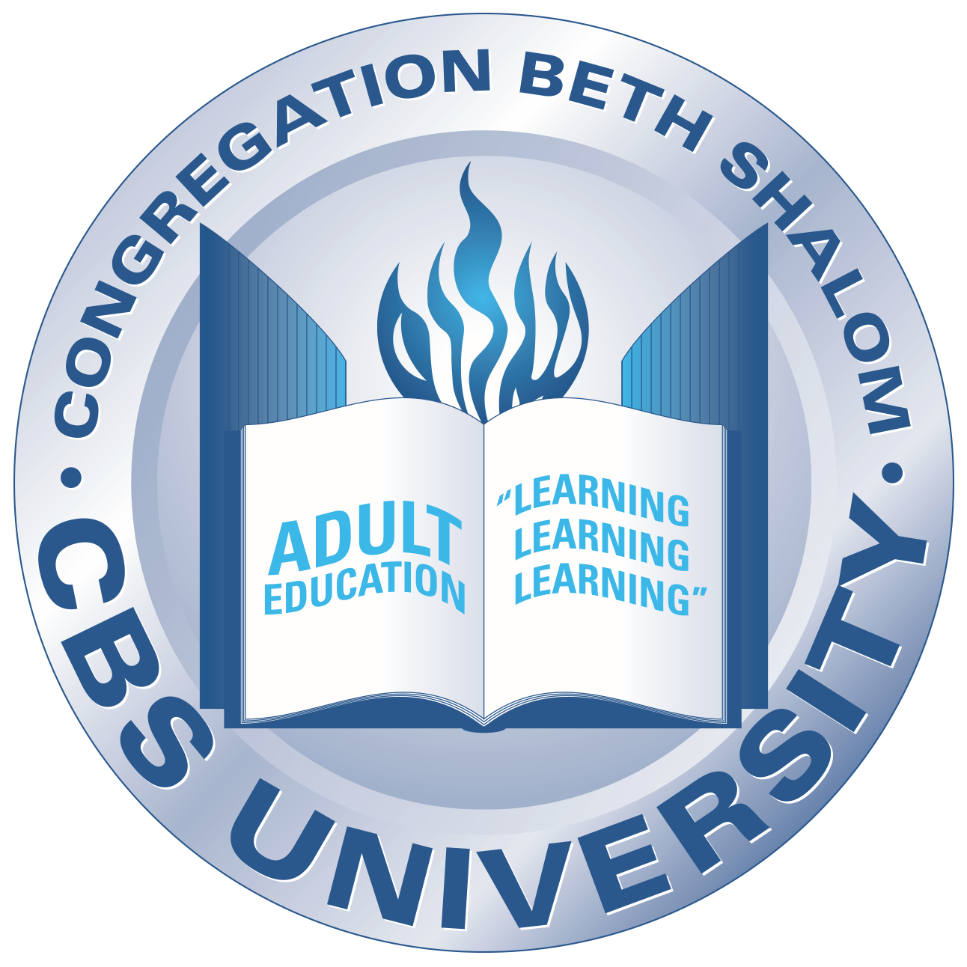
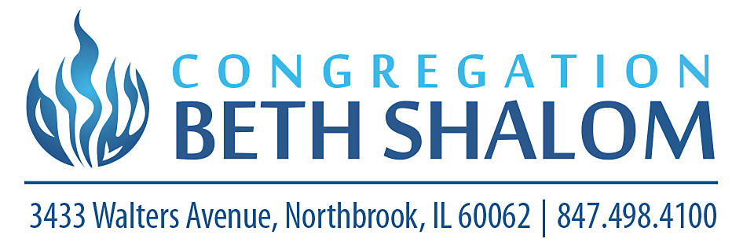
CBS University Class Offerings | Summer 2020

Hebrew from Aleph to Tav/
Greatest Hits of the Siddur
Instructor: Susan Stoehr
Date: June 8, 15, 22, 29
August 3, 10, 17, 24, 31
Time: 5:30 – 6:15 pm

NEW! Podclass
Instructor: Aaron Robbin
Dates: Mondays, July 6, 13, 20, 27
Time: 5:30 – 6:15 pm
A brand-new kind of class for CBS U! Listen to short, themed, entertaining podcasts before each class to frame and enrich our in-class discussion.

Talmud in Translation
Instructor: Rabbi Warner Ferratier
Dates: begins Monday, June 8th
Time: 6:30 – 7:40 pm

NEW! Parshat HaShavua – One Book, Many Voices
Instructor: Cantor Steven Stoehr & Friends
Dates: weekly Tuesdays, June 16 – August 18
Time: 9:30 – 10:20 am
Cantor Stoehr will explore the weekly Torah portion with a special friend each
Week. Special guests may include (in no particular order):
Rabbi Jeffrey Myers, Pittsburgh, Pa | Rabbi Adam Wohlberg, Dresher, PA
Rabbi Ari Averbach, Thousand Oaks, CA | Rabbi Aaron Brusso, Mt Kisko, NY
Rabbi Rachel Rubenstein, Middletown, NY | Cantor Hinda Eisen Labovitz, Chevy Chase, MD
Cantor Brian Mayer, Providence, RI | Reverend Thomas Stovall Chicago IL
Pastor Mark Smith, Elgin, IL | Cindy Preston, Akron, OH

Jewish News of the World
Instructor: Carl Schrag
Dates: begins Tuesday, June 9
Time: 10:30 – 11:30 am
Our conversation continues every week with news from around the world as it
Impacts our Jewish community.

NEW! Movies with Melman
Instructor: Rabbi Aaron Melman
Date: VARIOUS DAYS/DATES
1st session Tuesday, 6/9; 2nd session Tuesday, 6/23
Time: 7:00 – 8:00 pm
First session: watch The Frisco Kid before the discussion
Available to rent for $2.99 on: Amazon Prime, YouTube, Google Play, iTunes
Second session: Special guest, JONATHAN MUSSMAN of Netflix
Rabbi Melman will interview him about what’s new and exciting at Netflix!

NEW! Mahzor Analysis: Dive in Deep with Cantor Steve
Instructor: Cantor Steven Stoehr
Dates: Wednesdays, June 10, 24, July 8, 22, August 5, 19
Time: 6:30 – 7:30 pm
Explore some of the intricate passages of our High Holy Days.

NEW! Noshin ‘n Drashin with Michael Garlin
Instructor: Michael Garlin
Dates: Thursdays 6/25, 7/30 & 8/27
Time: 11:30 am – 1:00 pm
Your guess is as good as mine…I’ve left the discussion (MOSTLY) up to Michael!

Sippurei Musika
Instructor: Cantor Raquel P. Gershon
Date: Thursdays 6/11 & 18
For questions about these or any other CBS University classes or programs, email LBlue@BethShalomNB.org

Time: 10:30 – 11:15 am

